New Hartley First School
‘Happy children aiming high!’
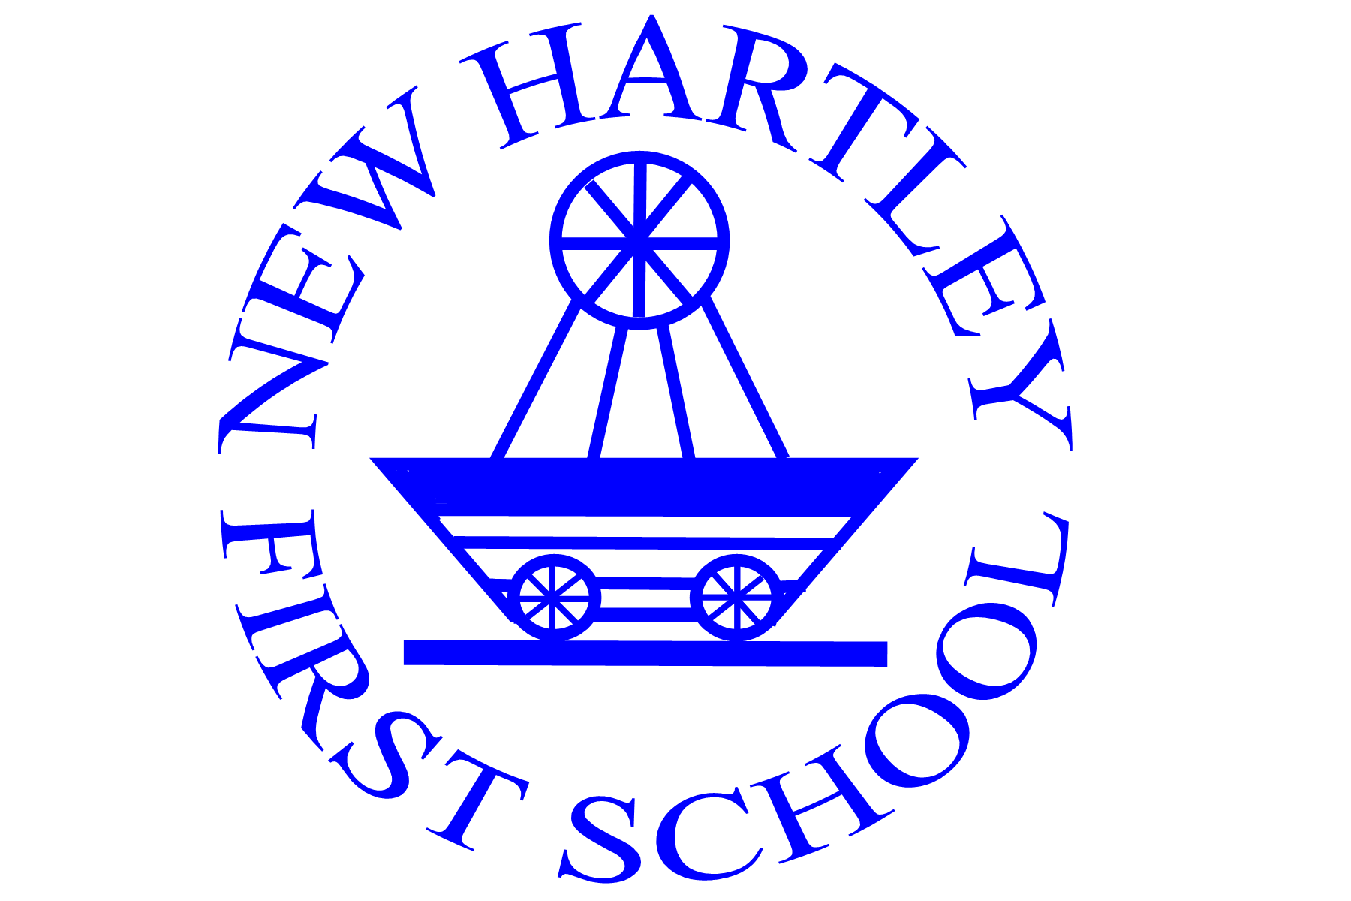

‘A good school with outstanding features.’ Ofsted September 2010

Admissions Policy for Nursery

Status: | Non - Statutory
Created/Reviewed | Summer 2012, Summer 2014
Next Review: | Autumn 2015

The standard number for nursery as set by the school is 26. Applications for nursery places should be received no later than the last day of the spring term. If the nursery is full any applications received after the closing date will be placed on a waiting list.

Admission Criteria

Children will be admitted in the Nursery Class, for 3 hours per day, no earlier than the term following the child’s third birthday. Intake is possible at the start of each term depending on places available. Offer letters will be sent at the following times:

- First half of summer term for an autumn term start
- First half of autumn term for a spring term start
- Second half of autumn term for a summer term start

A deadline for acceptance will be noted with the offer letter. If a reply is not received second letter will be sent with a further deadline for acceptance. If this deadline passes without a place being accepted the offer will be withdrawn and the place offered to another child. Where the demand for places exceeds the number available, places will be offered by applying the following criteria in decreasing order of merit:

Pupils who are age three by 31st August prior to the academic year in question and

- live in New Hartley: home address includes New Hartley

- children who are applying for five sessions per week

- children who have an older brother/sister who is expected to be on the New Hartley roll at the time of admission

- date of birth, eldest to youngest

- the child is being looked after by a child minder in New Hartley

- live in the area of a neighbouring school which does not have a
Nursery Class
- live anywhere else in Northumberland

- live outside the County of Northumberland

Should it prove necessary to distinguish between pupils priority will be given by applying the following sub-criteria in decreasing order of merit:

- Children on whose behalf evidence of exceptional medical, social or educational need is presented (this will normally have to be supported by a professionally involved third party);

- Children who live nearest to the school, measured in a direct line, home to school

If a nursery place is offered to your child, the following conditions will apply:

- There is no statutory right to a nursery place. If places are oversubscribed the
school will apply its admissions criteria to determine which children to admit.

If your child cannot be offered a place there is no right of appeal against that decision.

- Acceptance of a place must be made in writing by the stated deadline date.

- If an acceptance letter is not received a reminder letter will be sent with another deadline for acceptance.

- If this deadline passes without an acceptance letter being received by the school, the offer will be withdrawn. A letter notifying this course of action will be sent.

- Once a child is admitted to Nursery Class/School, regular attendance is expected.

- Your child will complete the nursery course and remain in the Nursery Class until he/she is eligible to transfer to full-time provision in a First School. (This requirement may be waived if, for example, you move house and it is no longer reasonable for your child to continue to attend this Nursery Class).

- The time for transfer from a nursery to a First School is at the beginning of the
Autumn Term if the child is four by 31st August.

When a child is due to start in a Reception class an application form must be completed. Application forms are sent by Northumberland LA not the school. The forms are usually distributed early November with a closing date towards the end of January. Completed forms can be returned to your preferred school or the LA. Notification of a place will be given by the end of April. Please note that you do not have the right to choose which school your child will attend, you only have the right to express a preference. The LA ability to meet the preference will be determined by the demand and the number of places available. The intake number at New Hartley for Reception in September 2014 is 26.

Full details of the admissions process can be found:
Northumberland County Website
Telephone - 01670 623562
email - schooladmissions@northumberland.gov.uk.

