Week Beginning 13th July 2020
Monday 13th July 2020
Phonics / Spelling | Reading / Writing | Maths | Physical | Foundation
Different ways of spelling the same sound - ow, oa, o-e  ow – blow the snow  oa – goat in a boat  o-e – phone home  Remember to use your yellow speed sounds book.  Words to learn this week:  one  two  three  four  five  six  when  year  Can you find any other words that use these sounds and add them to your list? | Objective: To listen to a poem. | Objective: To tell time to the hour | Objective: To be active as part of a heathy lifestyle | Key question: What is sound?
 | Link to lesson video and activities: https://classroom.thenational.academy/lessons/to-listen-to-a-poem-36da10 | Link to lesson video and activities:  https://whiterosemaths.com/homelearning/year-1/  Summer Term - Week 12 lesson 1 – Time to the hour | Complete Monday 13th Joe Wicks work out here:  https://www.youtube.com/channel/UCAxW1XT0iEJo0TYlRfn6rYQ | In today’s lesson, we'll be learning about sound. We will be specifically looking at what sound is and how to make sounds. This lesson will include identifying different volumes of sound. Lastly, we will be conducting an experiment to see if the sounds outside our home are the same in the morning compared to the sounds at night time.  https://classroom.thenational.academy/lessons/what-is-sound-ccdde4
 | What is a poem? – A poem is a collection of words that show an idea or an emotion in an imaginative way. Often, they include rhyming words, but not always. Our poems this week will include rhyming words. It is inspired by ‘Now We Are Six’ by AA Milne, it is called ‘Year Groups’.  Listen to the poem- provided in resources below.  Learn the poem off by heart.  Recite the poem at least twice all the way through so that you can remember all of the rhyming words.  Questions to answer:  What did the child master in Year 2?  What did the child earn in Year 3? | Telling the time can be a really tricky concept and is one that can only truly be learnt by doing it as part of daily life. Use what you learn this week and try to apply it as often as you can daily throughout the summer holidays. (bed time, school time, shop closing, train time?)  Can you draw and label all the numbers on a clock face? Remember to space out the numbers evenly and have 12 at the top, 6 at the bottom. (template provided in resources)  Count the numbers round, starting at 1.  A clock has two ‘hands’. They don’t look like hands but they point to the numbers on the clock to tell us the time.  The hour hand is short.  the minute hand is long.  What does 1 o’clock look like?  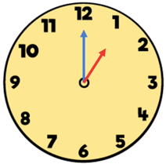  The minute hand is pointing to  the 12.  The hour hand is pointing to  the 1.  Take a look at Monday’s resources for more information and tasks. | Alternatively, use the Joe Wicks activity cards (Set 4) provided at the end of this planning document to guide your own work out.  These cards will be updated each week until the summer holidays so you will have four different workouts to keep and practice.
Tuesday 14th July 2020
Phonics / Spelling | Reading / Writing | Maths | Physical | Foundation
Different ways of spelling the same sound: ow, oa, o-e  ow – blow the snow  oa – goat in a boat  o-e – phone home  Can you spot the ‘ow’ sound in these words?  slow, throat, phone, throw, boat, stone  Sound them out and then blend the words.  Then ‘Fred in your head’ and say the words.  Finally read the words on sight, speedily.  Recap previous sounds: stray, plane, sprain,  Spellings – read the list provided in Monday’s planning.  Focus: four – note the ‘or’ sound ‘our’ – Think the word for the number ‘four’ has 4 letters. | Objective: To identify rhyming words. | Objective: To tell time to the half hour. | Objective: To be active as part of a heathy lifestyle. | Key question: How do we hear?
 | Use this link to complete today’s lesson: https://classroom.thenational.academy/lessons/to-identify-rhyming-words-fcb728 | Link to lesson video and activities:  https://whiterosemaths.com/homelearning/year-1/  Summer Term - Week 12, lesson 2 – Time to the half hour. | Complete Tuesday 14th Joe Wicks work out here:  https://www.youtube.com/channel/UCAxW1XT0iEJo0TYlRfn6rYQ | In today’s lesson, we will be learning about sound. We will be specifically looking at how our bodies allow us to hear sounds. We will then learn that not everyone has the ability to hear things and we will look at what deaf people may use to hear or communicate.  https://classroom.thenational.academy/lessons/how-do-we-hear
 | In this lesson, we are going to be identifying words that rhyme with the different numbers in our poem. This will help us when we write our own version later in the week.  First recap the poem – can you say the whole poem by yourself? Remember the order one to six. All lines start the same. The second line ends with a word that rhymes with the number word.  Identify the words that rhyme with the word in green. Remember to rhyme the words must end with the same sound, but they do not have to be spelled/look the same.  three – read, tree, fun, jump  five – pig, bike, pen, dive, read, egg  one – cone, three, run, two, fun, phone  two – new, owl, flame, four, blue, light  Now try these:  one – begun, start, begin, new  three – see, car, tea, man, dog, rock  four – cat, pick, paw, door, full, lit  six – fix, bird, axe, candle, tricks, paint  Challenge: Come up with your own rhyming words for these number words:  one, two, four, six | Today we are looking at time again, but this time to the half hour.  Remember a clock has two hands – the hour hand (short) and minute hand (long).  Look at these two clocks. What is the same? What is different?  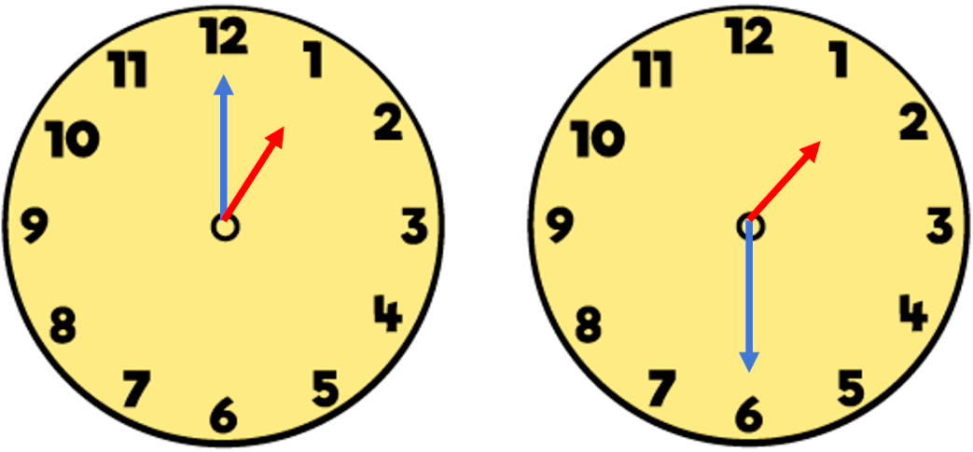  Did you notice that the minute hands have changed position? In the first clock the minute hand points at the 12 and the on the second clock the minute hand is half way round and pointing to the 6.  If you look closely you will also see that the hour hand has moved too. On the first clock it points at the number 1, but on the second clock the hour hand is half way between the 1 and 2 on the clock face.  What time is the first clock showing? (Recap yesterday’s session is this is too tricky.)  The second clock shows the time is half past 1 because the minute hand has moved half way round the clock to the number 6 and the hour hand is half way between the 1 and the 2. So it is half past 1.  Take a look at Tuesday’s resources for more information and tasks. | Alternatively, try ‘Transport Tuesday’  Can you stay active for at least 30 minutes using;  a scooter  a bike  a pogo stick  a skateboard  Remember to be careful and stay safe, always and stay in your garden or with an adult if you are outside your home.  Can you learn any new tricks?
Wednesday 15th July 2020
Phonics / Spelling | Reading / Writing | Maths | Physical | Foundation
Different ways of spelling the same sound: : ow, oa, o-e  ow – blow the snow  oa – goat in a boat  o-e – phone home  Read the words, underline the ‘ow’ sounds: flown, goat, rose, roam, globe,  Sound them out and then blend the words.  Then ‘Fred in your head’ and say the words.  Finally read the words on sight, speedily.  Spelling focus: year – break it into two sounds: y-ear  Write it at least 3 times.  two – remember the word for number 2 is different to the other spellings we know of this word. | Objective: To plan a poem. | Objective: To write the time. | Objective: To be active as part of a heathy lifestyle. | Key question: How can we describe the pitch of sounds?
 | Use this link to complete today’s lesson: https://classroom.thenational.academy/lessons/to-plan-a-poem | Link to lesson video and activities:  https://whiterosemaths.com/homelearning/year-1/ Summer Term - Week 12, lesson 3 – Writing time | Complete Wednesday 15th Joe Wicks work out here:https://www.youtube.com/channel/UCAxW1XT0iEJo0TYlRfn6rYQ | In today’s lesson we'll be learning about sound. We will be learning about how sounds can sound different. Some have a high noise called high pitch and some have a low sounding noise called low pitch. We will be looking at how vibrations can change the pitch.  https://classroom.thenational.academy/lessons/how-can-we-describe-the-pitch-of-sounds
 | In this lesson, we are going to plan our own poems, thinking carefully about what we learnt about rhyming in yesterday’s session.  Fold a piece of paper or draw a grid like the one below:  one  two  three  four  five  six  In the empty box write and draw words that rhyme with the number word on the left.  Try to think of some of your own rather than copy the ones from the poem.  If you can think of more than one, write and draw them all. You can choose which to use in your poem later in the week.  Now use your rhyming word plan to start to play around with the words and see if you can come up with your own rhyming poem – you do not need to write this down, just play with the words. | Today we will be focusing on how to write time and thinking about the units of time (seconds, minutes and hours).  How much time does it take?  Seconds – one second is a very short time. You could probably only blink your eyes two or three times in one second.  Minutes – one minute is still quite a short space of time. It is 60 seconds. You could probably write a short sentence in one minute, but you couldn’t write a whole page in one minute.  Hours – one hour is a longer period of time. One hour is made up of 60 minutes. We would measure how long we were at school or how long we slept through the night in hours.  We are going to think about some of the things we do and whether we would describe the time it takes to do them in seconds, minutes or hours.  e.g. To wash your hands? At least 20 seconds, but sometimes it could take 2 minutes to wash and dry our hands properly.  To watch a film? It usually takes approximately 2 hours to watch a film.  To drink a small glass of water? It probably only takes a few seconds to drink a small glass of water.  Take a look at Wednesday’s resources for more information and tasks. | Alternatively, use the Joe Wicks activity cards (Set 4) provided at the end of this planning document to guide your own workout.  These cards will be updated each week until the summer holidays so you will have four different workouts to keep and practice.
Thursday 16th July 2020
Phonics/Spelling | Reading / Writing | Maths | Physical | Foundation
Different ways of spelling the same sound: ow, oa, o-e  ow – blow the snow  oa – goat in a boat  o-e – phone home  Can you read these sentences and spot all the different ‘ow’ sound spellings?  To get home I had flown and taken a boat.  I gave a croak from my bad throat and put my head on the pillow.  Spelling focus: when – the ‘w’ sound is spelt with a ‘wh’. Write the word 3 times.  Cover the list from this week and see how many you can spell correctly. | Objective: To identify syllables. | Objective: To compare time. | Objective: To be active as part of a heathy lifestyle. | Key question: How can we make and describe different sounds?
 | Today’s lesson link: https://classroom.thenational.academy/lessons/to-identify-syllables-a88e47 | Link to lesson video and activities:  https://whiterosemaths.com/homelearning/year-1/  Summer Term - Week 12, lesson 4 – Comparing time. | Complete Thursday 16th Joe Wicks work out here:  https://www.youtube.com/channel/UCAxW1XT0iEJo0TYlRfn6rYQ | In today’s lesson we'll be bringing together all our knowledge from this unit. We will be making lots of sounds using our bodies, while discussing how we can describe different sounds by their pitch or volume. Then we will be trying to find high pitch and low pitch sounds using utensils from the kitchen. We will finish the lesson with a sound experiment for you to do in your own time.  https://classroom.thenational.academy/lessons/how-can-we-make-and-describe-different-sounds
 | In this lesson, we are going to be learning all about syllables. You will need your clapping hands at the ready to count the syllables in words and sentences.  A syllable is a unit of sound e.g. sy-lla-ble – 3 units of sound.  Clap and count the syllables in these words:  cat – cat -1 syllable.  over – o/ver - 2 syllables  banana – ba/na/na - 3 syllables  information – in/for/ma/tion – 4 syllables  Can you identify and clap how many syllables are in these sentences?  The cat is black. (4)  My bottle is blue. (5)  I learnt how to just be me. (7)  I learnt how to swim and dive. (7)  Try saying some simple sentences of your own and count the syllables. | Today we are talking about comparing time. When we compare time we look at two different activities and we can use the vocabulary; earlier, later, slower, faster, first, last.  Think about the words we use to describe time: day, hour, second, month, minute, week  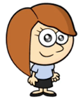  Put these words in order from least amount of time to greatest amount of time. (second, minute, hour, day, week, month)  Rosie is at the beach.  Think about some of the things she could do at the beach. Which would be faster or slower? Take two activities and compare them using the words faster or slower.  - filling a bucket  - building a sandcastle  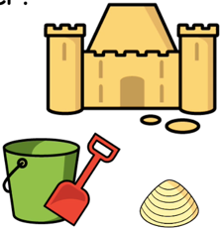  - picking up a shell  Take a look at Thursday’s  resources for more  information and tasks. | Alternatively, use the Joe Wicks activity cards (Set 4) provided at the end of this planning document to guide your own workout.  These cards will be updated each week until the summer holidays so you will have four different workouts to keep and practice.
Friday 17th July 2020
Phonics/Spelling | Reading / Writing | Maths | Physical | Foundation
Different ways of spelling the same sound: ow, oa, o-e  ow – blow the snow  oa – goat in a boat  o-e – phone home  Can you write the different ways of spelling ‘ow’ we have been learning this week?  Spelling quiz/check.  Write each of the words your grown up tells you from the list we have been learning.  Think carefully about which spelling of the ‘ow’ sounds you need.  You may want to write these words in sentences or phrases too. | Objective: To write a poem. | Objective: To use reasoning and problem-solving skills | Objective: To be active as part of a heathy lifestyle. | Objective: To relax and find calm
 | Use this link to complete today’s lesson: https://classroom.thenational.academy/lessons/to-write-a-poem | Family Friday Challenge!  Challenge 1:  Sam has some red and yellow cubes.  She has 20 cubes in total.  She has 8 more yellow cubes than red ones.  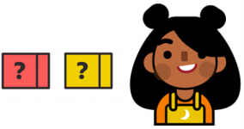  How many red cubes does she have?  Challenge 2:  Jon thinks of a number.  Half of his number is 12.  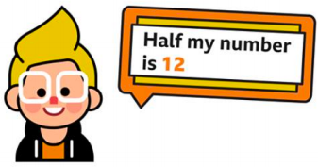  What is one quarter of Jon’s number?  Remember, start with what you do know to work out what you don’t know.  Use pictures or objects to help too! | Complete Friday 17th Joe Wicks work out here:  https://www.youtube.com/channel/UCAxW1XT0iEJo0TYlRfn6rYQ | Final Feel Good Friday!  To continue to look after your mental and physical wellbeing take some time today to be kind to yourself and nurture your mental health.  We all have different ways of doing this. This week I am hoping to visit my daughter in her new flat and help her decorate it ready to move in. This may sound like lots of work, but to see her happy and settled in her new home will bring me lots of happiness too. Sometimes doing something nice for other people can make you feel good too!  Think about what you could do to help someone else without expecting anything in return.
 | In this lesson, we are going to be writing out our poems combining our work on rhyming and our knowledge of syllables.  You will need your rhyming plans from Tuesday and be ready to play around with the words/syllables in your poem.  Write the title: Year Groups  Write the first line of your poem:  When I was in Year One (capital letters for group name)  Now count the syllables in the line. (6)  Can you compose a line that rhymes with this one that also has 6 syllables? e.g:  I first learnt how to run. (6)  You may need to play around with the words until you match the same number of syllables to make a line that makes sense and rhymes with ‘one’.  Repeat for Year Two e.g.  When I was in Year Two (6)  Everything was so new (6)  Continue until you have completed all year groups to Year Six.  Check your work:  - Capital letters to start each line  - Matching numbers of syllables  - Rhyming words in each verse  - Full top at the end of the second line in each verse. |  | As it is our final ‘feel good Friday’, use the provided yoga poses to help you stretch. If you have been using these each week, you will now be able to recognise the poses by name and have developed your flexibility and strength to hold these poses for longer and with increased control.  (See sheet at the end of this planning pack)  If you can, play some calming instrumental music too.  Remember: Never continue to bend or stretch or hold a pose if you become uncomfortable. Listen to your body, it will tell you when to stop. We are all different and can stretch, twist or bend differently.
Poem – inspired by “Now We Are Six’ by AA Milne

Year Groups

When I was in Year One,
I learnt how to have some fun.

When I was in Year Two,
I learnt how to make a stew.

When I was in Year Three,
I learnt how to be just me.

When I was in Year Four,
I learnt how to fix a door.

When I was in Year Five,
I learnt how to swim and dive.

When I was in Year Six,
I learnt how to make cake mix.

Monday Maths Tasks
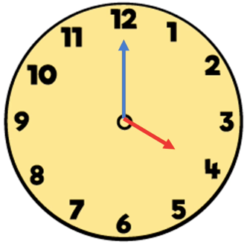
1. What does 4 o’clock look like? 2. Now look at these clocks and see if you can say what time they show.
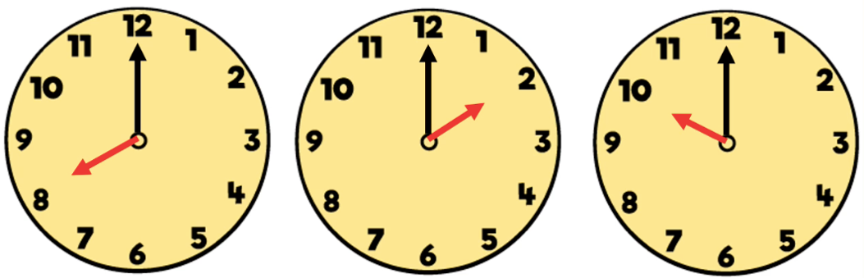

The minute hand is pointing to the 12.
The hour hand is pointing to the 4. It is ____ o’clock. It is ____ o’clock. It is ____ o’clock.

3. Now try these. Look closely at the ‘hands’ on the clock face. They are the same colour now, but still different sizes. Can you remember which is which? If not look at the examples again to remind yourself.
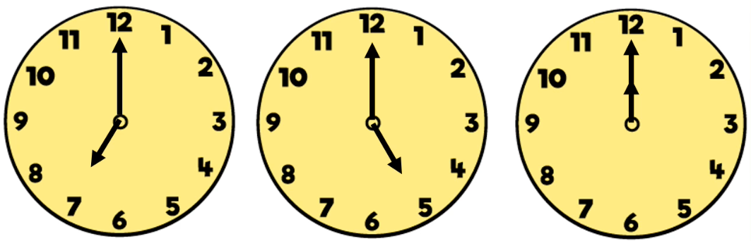
4. Time never stops! Your next job is to look at the clocks and see
what time they are showing now. Then think about what time it
will be in 1 hour.
Here is an example:
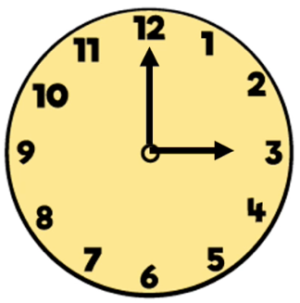
Now: 3 o’clock.
It is ____ o’clock. It is ____ o’clock. It is ____ o’clock. In 1 hour: 4 o’clock because 1 more than 3
is 4. That is the same when we count in
5. Try these yourself: hours too.
What time is it now?
What time will it be in 1 hour?
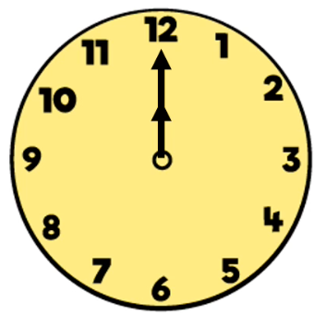
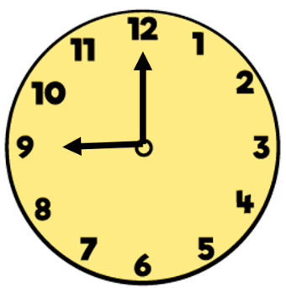
Now: ____ o’clock Now: ____ o’clock Additional or
In 1 hour: ____ o’clock In 1 hour: ____ o’clock alternative White Rose
Maths worksheets are
available on our class
webpage.
6. Whitney is showing us what time she does things during the day. Can you read the time and complete the statements?
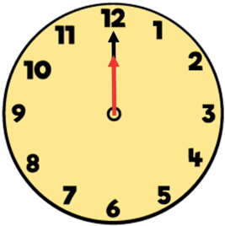
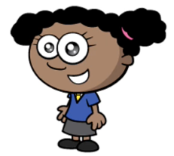
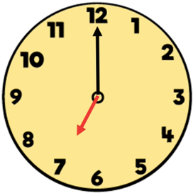

I get up at ____ o’clock. I have lunch at ____ o’clock.

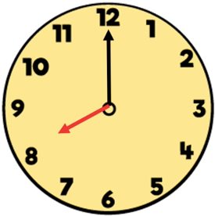

I go to bed at ____ o’clock.

7. Mr Smith is showing us what time he does things during the day. Can you read the time and complete the statements?
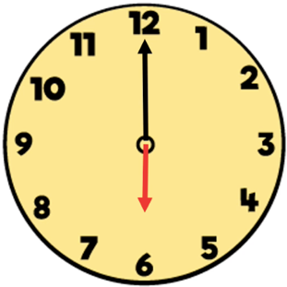
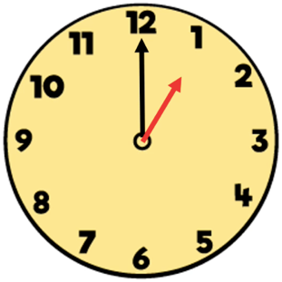
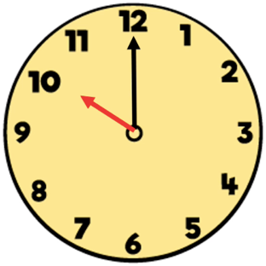

I wake up at ____ o’clock. I eat lunch at ____ o’clock. I go to bed at ____ o’clock.

8. Challenge: Can you draw clock faces to show the times (to the nearest hour) that you get up, eat lunch and go to bed?

Alternative or additional White Rose Maths worksheets are also available on our class webpage.

Tuesday Maths Tasks
1. Can you describe what What does half past Look closely. 2. Have a go at
4 o’clock looks like? 4 look like? The minute hand is pointing half completing the
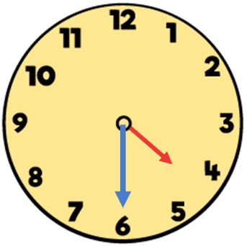
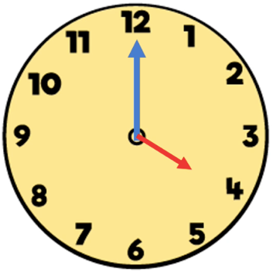
way round the clock to the number 6. times below.
The hour hand is pointing Explain your
half way between the 4 and 5. thinking aloud.
The clock says:
It is half past 4

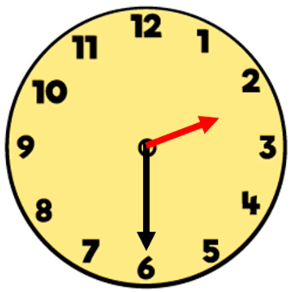
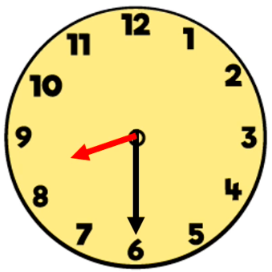
2.
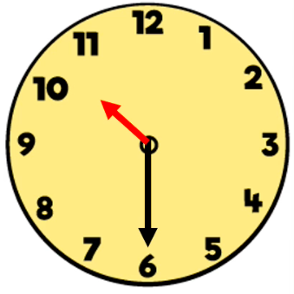

It is ________ ________ ____ It is ________ ________ ____ It is ________ ________ ____

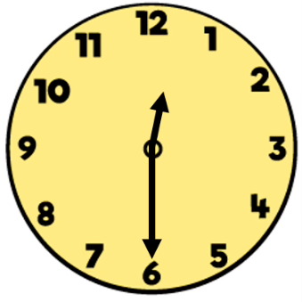
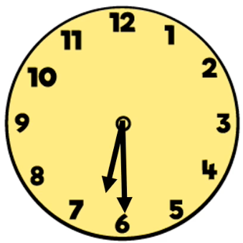
3. Now try these. Look closely at the ‘hands’ on the clock face. They are the same colour now, but still different sizes. Can you remember which is which? If not look at the examples again to remind yourself.
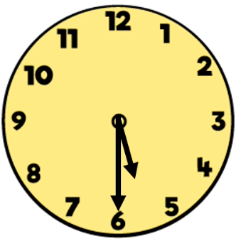

It is ________ ________ ____ It is ________ ________ ____ It is ________ ________ ____
4. What time is it now? What time will it be in half an hour? The first one has been done for you. Use it as an example to help you.
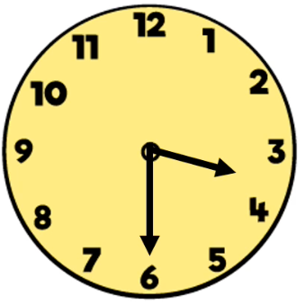
Now: half past 3 The minute hand will move another half turn to be pointing at the 12 again.
In half an hour: 4 o’clock The hour hand will continue to move from half way between the 3 and 4, to be
exactly on the 4.

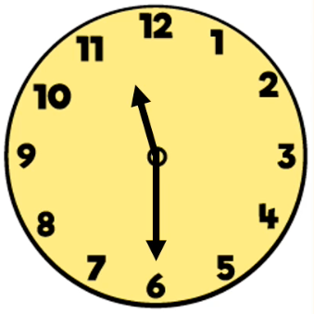
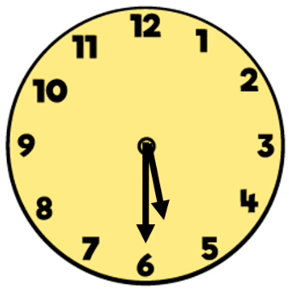
Now: half past ___ Now: ________ ________ ___
In half an hour: ___ o’clock In half an hour: ___ ___’ ______________

5. Whitney is showing us the times she does things during the day. Can you read the time and complete the statements?
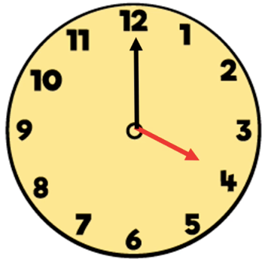
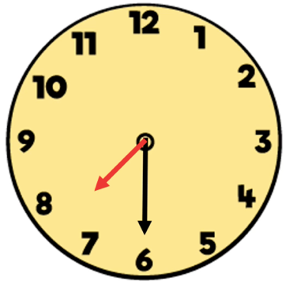
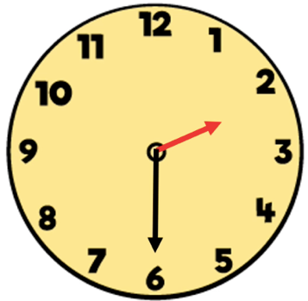

I eat breakfast at I finish school at I start piano lessons at
half past ___. ________ ________ ___. ___ ___’ ____________.
6. Mr Smith is showing us the times he does things during the day. Can you read the time and complete the statements?
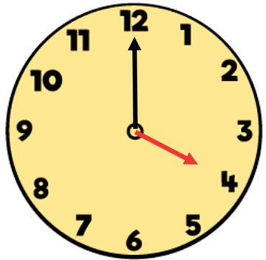
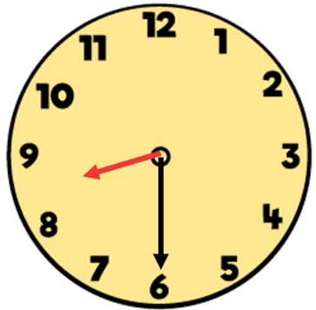
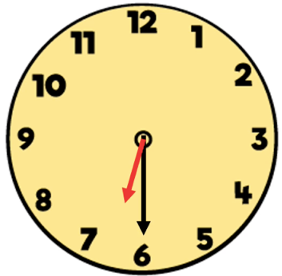

I eat breakfast at I leave work at I watch TV at
half past ___. ___ ___’ __________. ________ ________ ___.

7. Challenge: Can you draw clock faces to show the times (to the nearest half hour) that you do things at home?

Alternative or additional White Rose Maths worksheets are also available on our class webpage.

Wednesday Maths Tasks
1. How long? Seconds, minutes or hours?

To brush your teeth? It should usually take ____________________ to brush my teeth.

To fill a bowl of cereal? 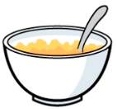 It should usually take ___________________ to fill a bowl of cereal.

To take a plane ride to Australia? 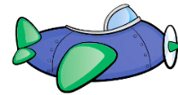 It would take _______________ to fly to Australia from England.

2. What could you do in 4 seconds? Try them out. 3. What could you do in 5 minutes? Try them out.
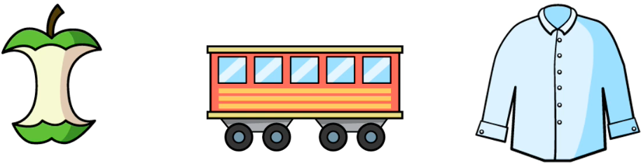
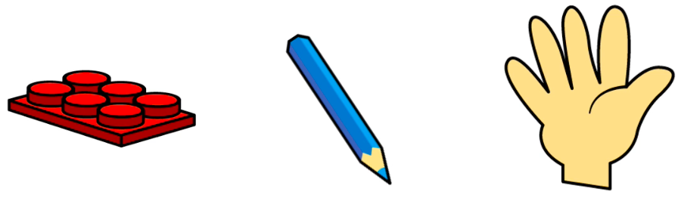
Build a castle Write 1 – 5 Clap 10 times Eat an apple Take a train ride Change your clothes
to another city

4. What could you do in 2 hours? Think about it. 5. Thinking about seconds, minutes or hours.
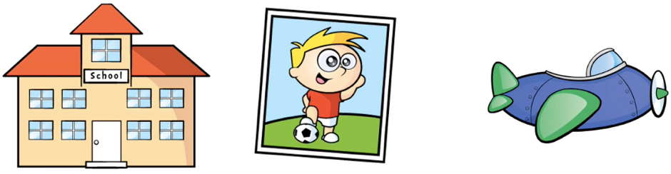
Would you rather?
Play your favourite game for…
Wait for a train for …
Clean your room …
There is no right or wrong answer, just something to think about!
A day at school A football match Fly on holiday

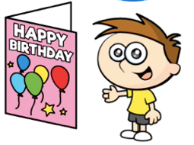
6. Teddy is having a birthday party. Thinking of seconds, minutes or hours:

How long will…

It take to make the cake? It take to blow out the candles? It take to eat the cake?

_______________________ ___________________________ ________________________

It take to decorate the house? It take to wrap a present? It take to unwrap a present?

________________________ ____________________________ _________________________

The party last?

________________________

Alternative or additional White Rose Maths worksheets are also available on our class webpage.

Thursday Maths Tasks
1. Let’s compare going to school on a bike, in a car and walking.
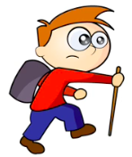
If these people all started at the same spot and all went to the same school which would take:
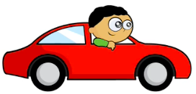
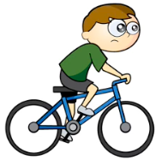
- 2 hours
- 30 minutes
- 8 minutes

If they all left at the same time, who would get there…
- first?
- second?
- last?

2. Here we have a bucket, a pool, a glass and a bottle.
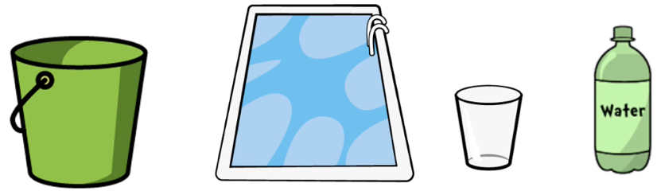
If we started filling them all at the same time;
Which would be the fastest to fill?
Which would be the last to fill?
Which of these would fill in seconds / minutes / hours?
Talk about it and explain your thinking.

3. Let’s compare trains. If the blue train takes 35 minutes to 4. The blue train leaves at: The green train leaves at:
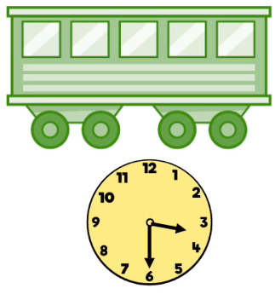
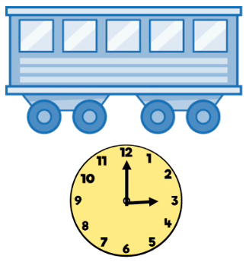
get to the next stop and the green train takes 53 minutes to
get to the next stop.

35 minutes 53 minutes

Which train is faster? Which train leaves later?

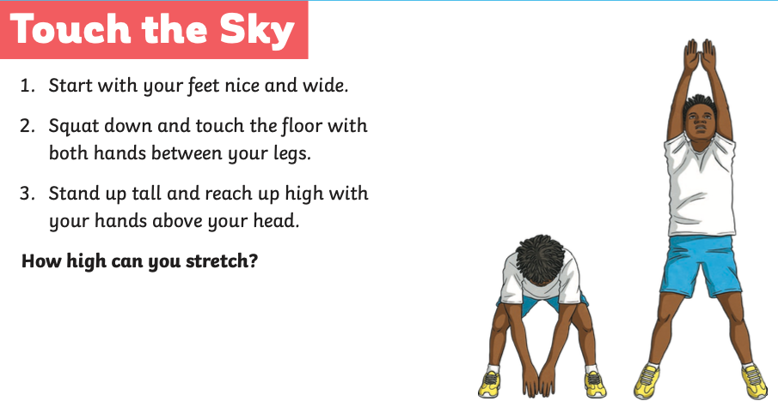
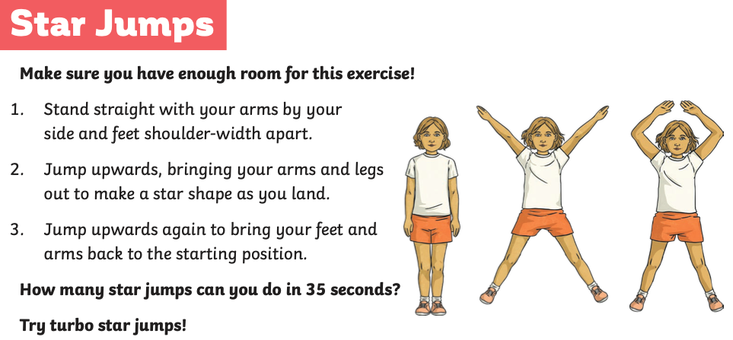
REST
REST
Joe Wicks 8-minute workout 4
These cards have been created to illustrate the exercises demonstrated by Joe in his workout videos. You can use the cards by themselves or watch the video for this work out here, select Active 8, Workout 4: https://www.twinkl.co.uk/resources/twinkl-move/joe-wicks-twinkl-move
Each exercise is performed for 35 seconds, with a 25-second rest in-between but you can make this harder by repeating the exercise for up to 1 minute with a 1 minute rest in between.

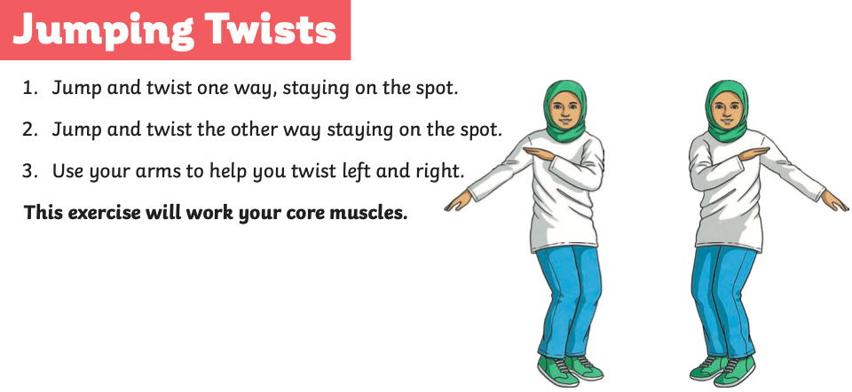
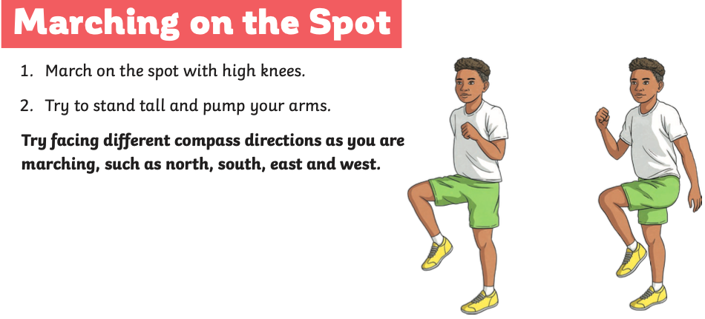
REST
REST

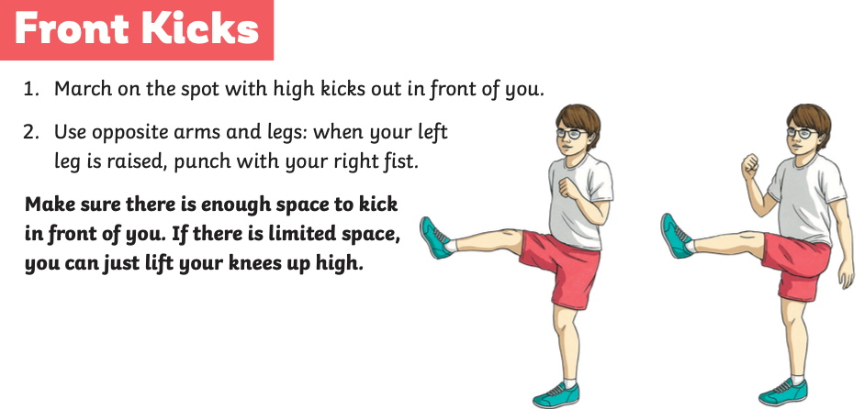
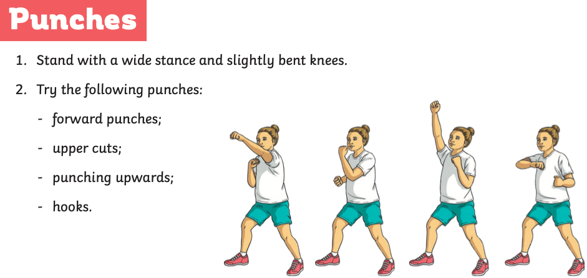
REST
REST
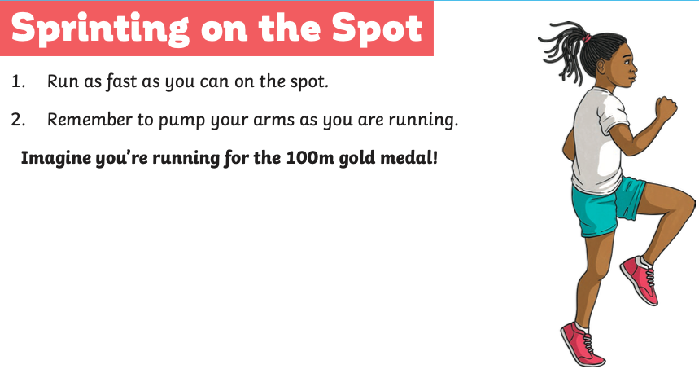
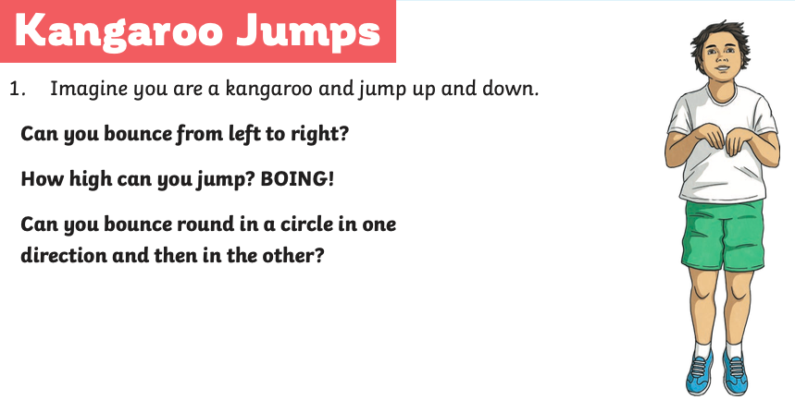
REST
REST
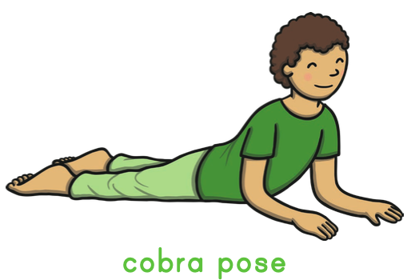
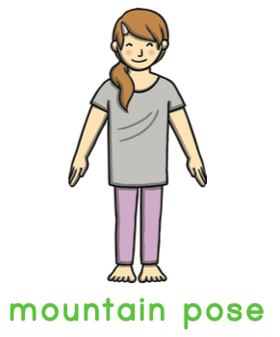
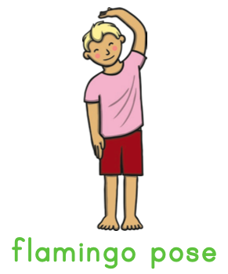
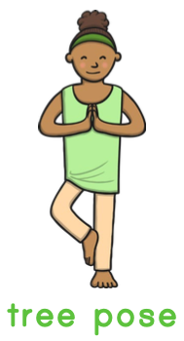
Yoga poses:
