

**Expressive Arts and Design**

* Making Poppies to help us find out about Remembrance Day
* Firework chalk drawings and paintings. Making our own firework rockets with junk modelling
* Making dinosaur skeletons using different media
* Painting our own dinosaurs

**Understanding the World**

* Finding out facts about dinosaurs
* Where did dinosaurs live
* Finding out about Bonfire night and fireworks night
* Learning about Remembrance Day
* Reading the Nativity story
* Talking about our family Christmas traditions

****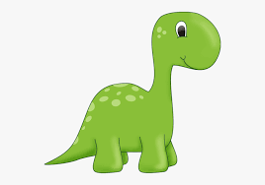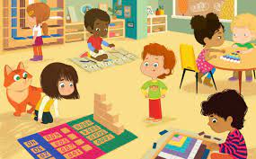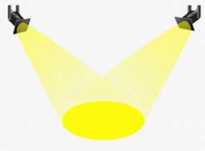

Our Whole school theme is **Aspirations.** Children will be thinking about their dreams! Would they like to work with dinosaur artefacts? Would they like to explore numbers? Be an author?

**Key Questions**

* What dinosaur names do I know?
* What dinosaur stories do I like?
* What do I want to know about dinosaurs?
* How big is a dinosaur footprint?

**PSED**

* Anti Bullying week 15th November-
* Links with school PSCHE scheme-Courage-trying new things, -Helpfulness-who helps you-Kindness-creating an alphabet of kindness

We will continue to encourage children to develop a Growth Mindset approach to learning by using our mantra **“When we learn we grow!”**

**Literacy**

* Daily Read Write Inc activities to develop our knowledge of phonics
* Dinosaur stories and Christmas Stories
* Reading Spine books-Gruffalos child, Whatever Next
* Writing our Christmas lists and letters to Father Christmas

**Physical development**

* Daily Dough Disco sessions to help make our hands strong with writing
* Daily Squiggle while you wiggle sessions to help with our gross motor and fine motor movements

**Maths**

Maths week 9th November

* 1, 2 3 it’s Me! –Exploring the composition of 1 2 and 3
* Exploring 1 and 3 sided shapes-circles and triangles
* Using positional language e.g. next to, behind, in front
* Looking at light and dark times of the day
* Finding out about numbers 4 and 5
* Exploring shapes with 4 sides-squares

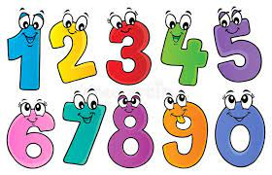

**Our Early Years theme this half term is…**

**Dinosaur, Roar!**

**Communication and Language**

**Key Vocabulary**

Dinosaur, dinosaur names, bones, prehistoric, fossil, extinct, palaeontologist

* Asking questions about dinosaurs
* Using key vocabulary
* Playing listening and attention games
* Talking about our own experiences of special occasions-e.g. fireworks night and Christmas

**Career spotlight**

* Finding out about the job of a palaeontologist
* Talking about authors and illustrators when we explore books
* Talking about people who help us in our PSED activities

**Focus Texts**

* Dinosaur Roar
* Hideasaurus
* Tyrannosaurus drip
* Harry and the bucketful of dinosaurs
* The dinosaur who pooped Christmas
* Christmas stories

**Continuous provision enhancements**

* Building dinosaur homes
* Small world play with dinosaurs
* Sensory enhancements e.g. green spaghetti to make a dinosaur swamp, sparkly water for Christmas, decorating Christmas trees
* Role play-dinosaur bone investigations, Santa’s workshop/post office
* Themed play dough mats to support vocabulary



**Visits and Visitors**

* NUFC weekly PE sessions (multi-skills)
* Weekly Yoga sessions
* Weekly FUTSAL motor skills session on a Friday with Liam
* Virtual museum visits to the Natural History ,museum in London
* Christmas event with Tiddlywinks with a special visitor!



**Information and Reminders**

* Please remember to name children’s clothes
* Reception PE day is Wednesday

Any questions please see a member of Early Years